**Appendix A - Application Screens and Design Mockups**

*All screens are relevant for version 1.0 (Excluding MVP)

**1. Registration Screen**

**Description:** Enables to register by verifying their phone number, accepting terms, and providing personal details such as name and birthdate.

**Designated User Type:** Protegee and Trusted Contact.

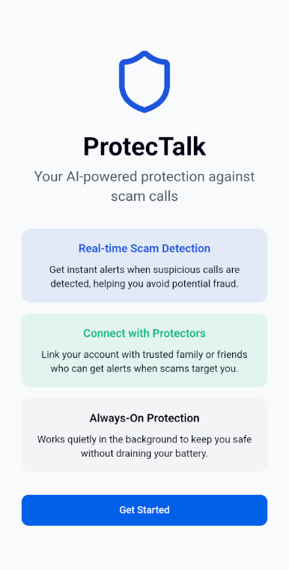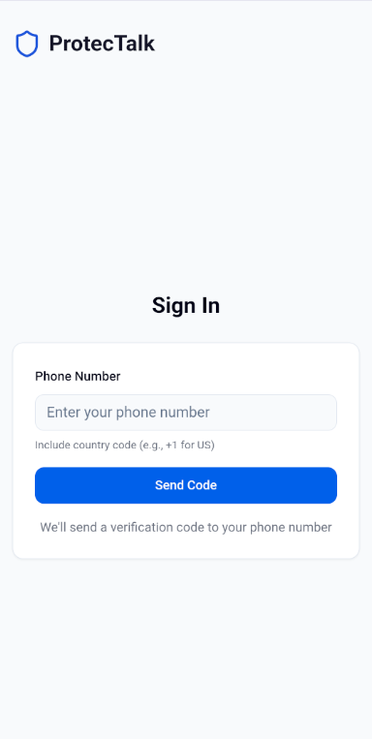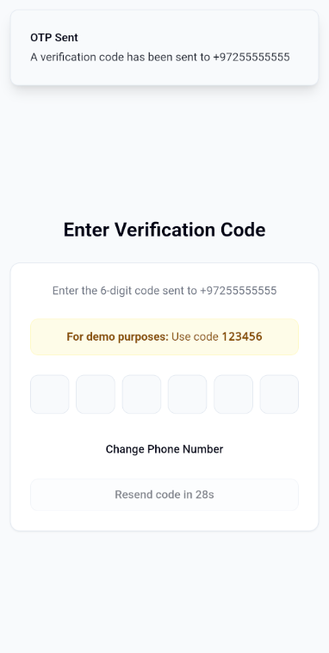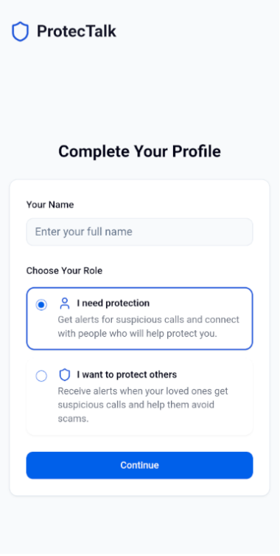

**2. Login Screen**

**Description:** Allows returning users to log in using a 6-digit verification code sent to their phone number. Successful login redirects the user to the main application screen.

**Designated User Type:** Protegee and Trusted Contact.

 

**3. Incoming Call Evaluation Screen**

**Description:** Automatically activates when a call from an unknown number is detected. Verifies if the number exists in the user’s contacts and queries a remote fraud database.

**Designated User Type:** Protegee

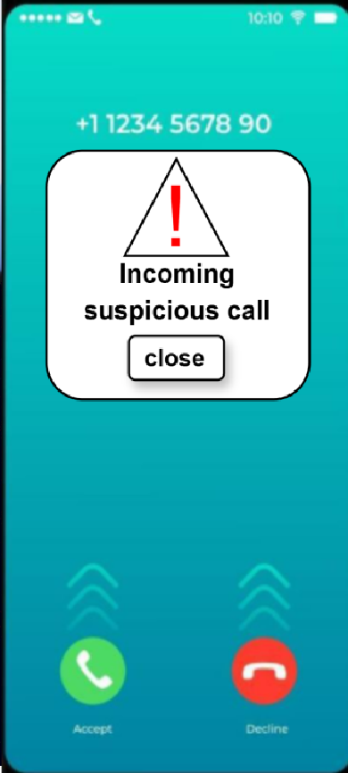

**4. Scam Risk Alert Screen**

**Description:** Uses a traffic light visual system (Green, Yellow, Red) to inform the user of the scam likelihood during an active call, based on AI evaluation.

**Designated User Type:** Protegee

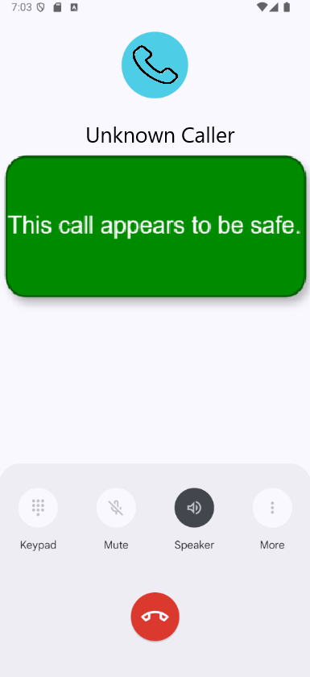 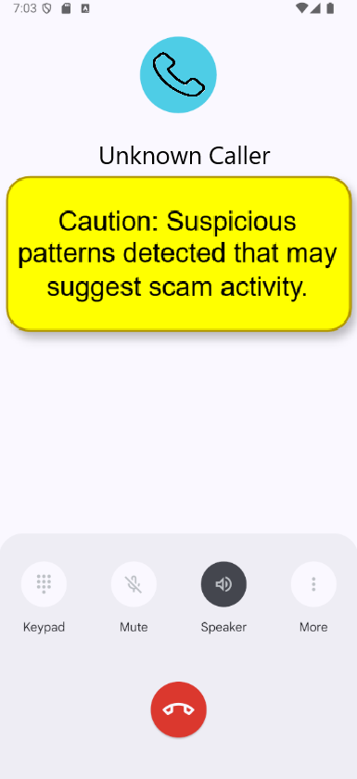 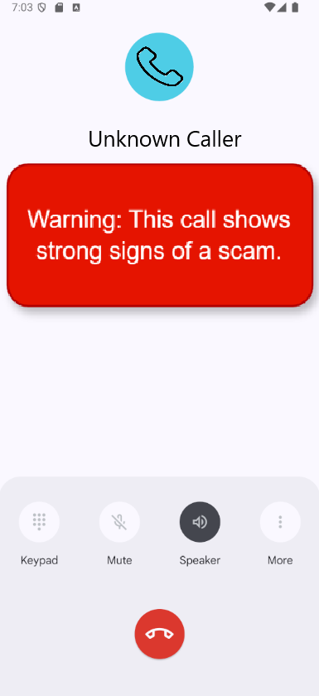

**5. Trusted Contact Notification Screen**

**Description:** Sends alerts to trusted contacts when a high scam risk is detected or when the application is uninstalled by the protegee.

**Designated User Type:** Trusted Contact

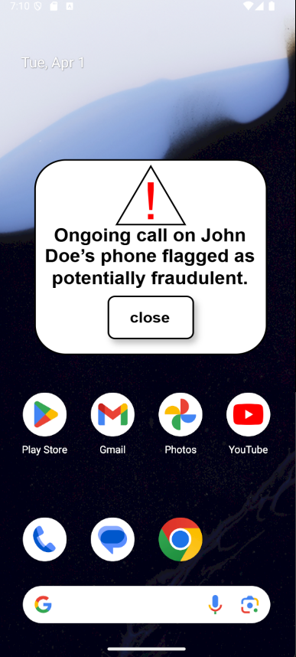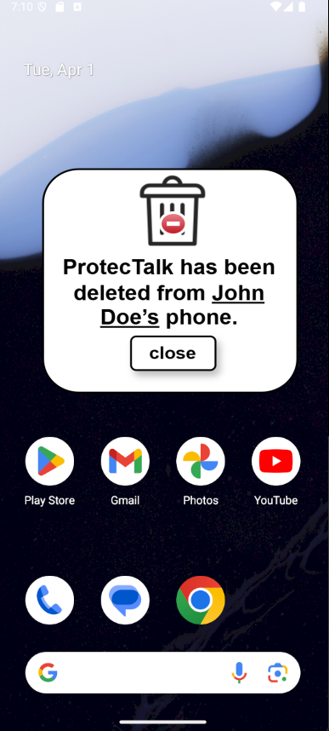

**6. Protegee Feedback Screen**

**Description:** After a call ends, the protegee can choose to submit the transcript to help improve scam detection.

**Designated User Type:** Protegee

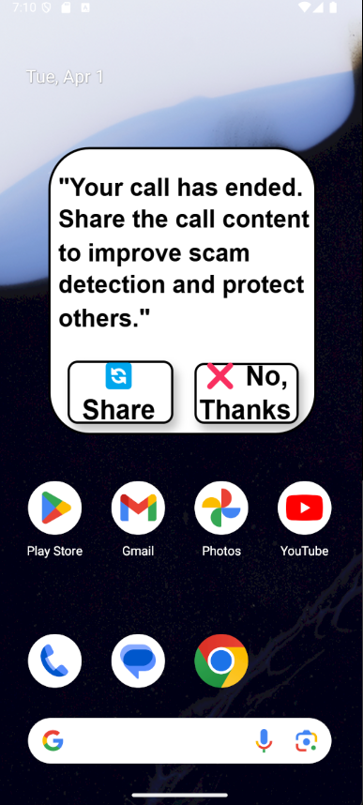

**7. Trusted Contact Feedback Screen**

**Description:** After a call ends, trusted contacts can provide feedback on the call’s legitimacy.

**Designated User Type:** Trusted Contact

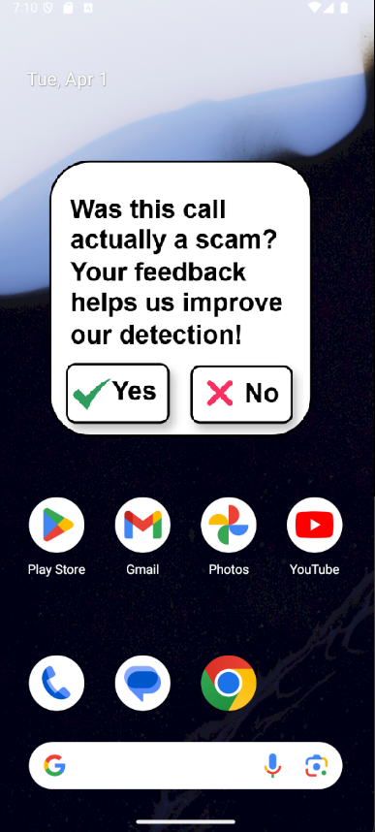

**8. Protection Request Review Screen**

**Description:** Displays incoming and outgoing protection requests. Enables users to approve, reject, or track the status of connection attempts.

**Designated User Type:** Protegee and Trusted Contact

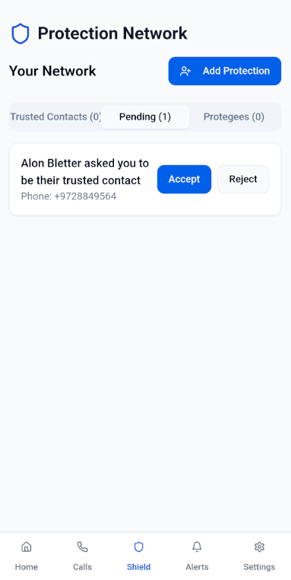

**9. Protection Management Screen**

**Description:** Lists existing protection relationships and allows users to remove a connection. Updates are communicated to the affected user.

**Designated User Type:** Protegee and Trusted Contact

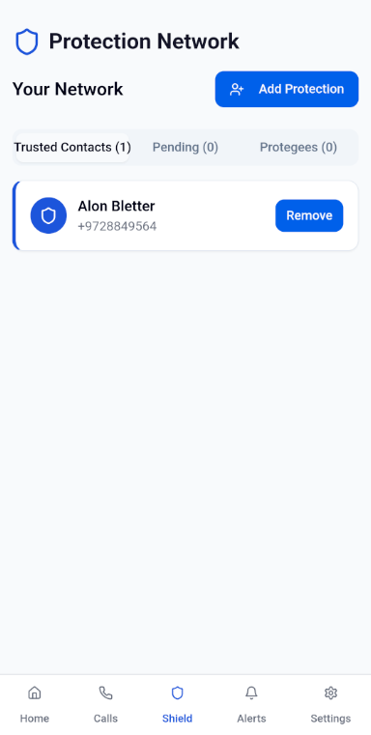

**10. Protection Setup Screen**

**Description:** Allows users to initiate protection relationships by entering the other party’s phone number, name, and relationship. The request process follows a two-way approval flow.

**Designated User Type:** Protegee and Trusted Contact

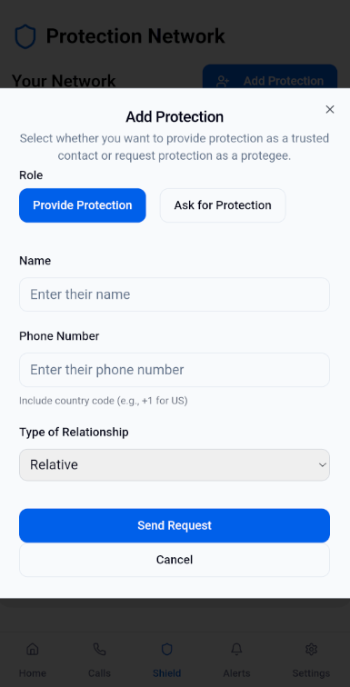

**11. User Dashboard**

**Description:** This section covers the core screens that provide users with access to their personal information and app preferences. It includes profile details, application settings, home screen, call history, and customizable preferences that enhance user experience and control.

**Designated User Type:** Protegee and Trusted Contact

